**DBMS LAB ASSIGNMENT 3**

**1. Relational Model.**

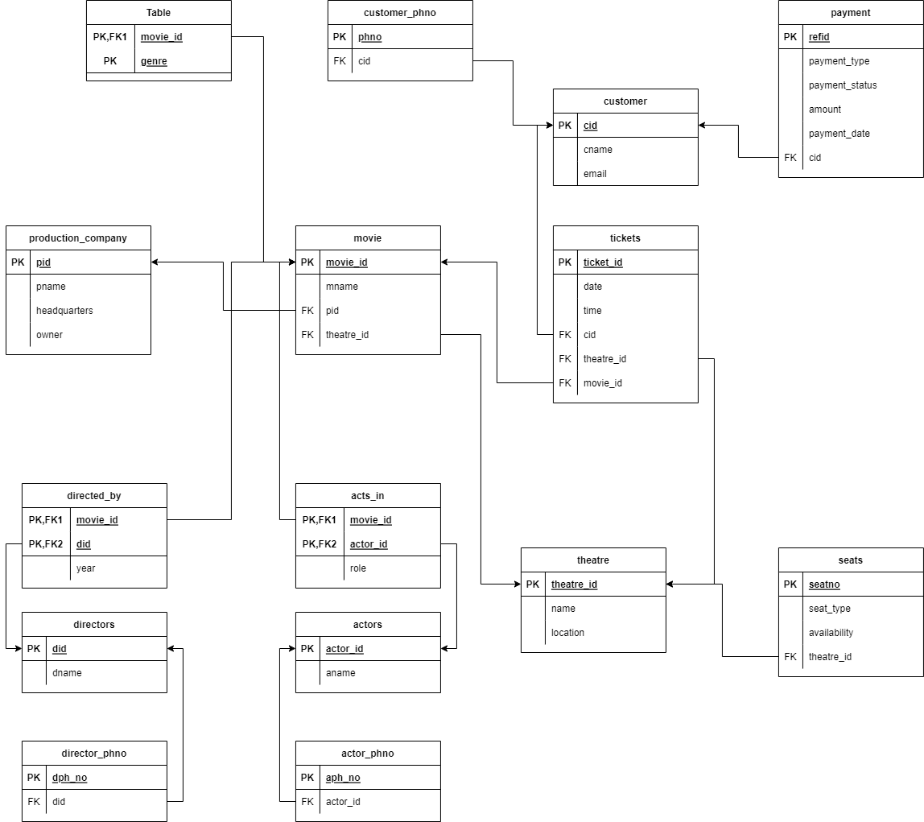

**2. Creating tables in the database based on Relational Mapping**

* Customer

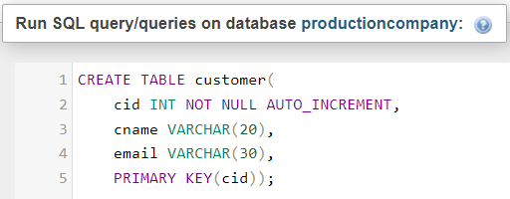

* Customer_phno

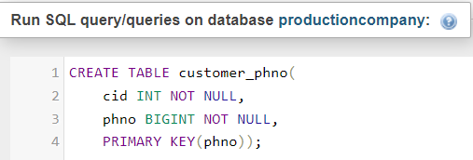

* Payment

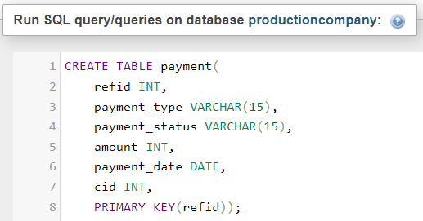

* Tickets

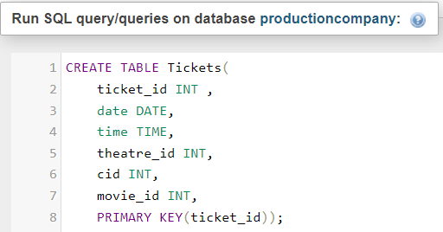

* Movies

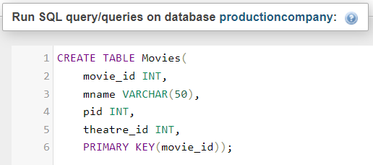

* Genre

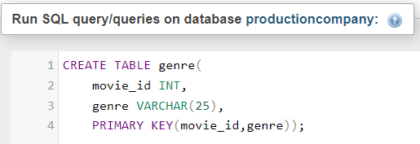

* Production Company

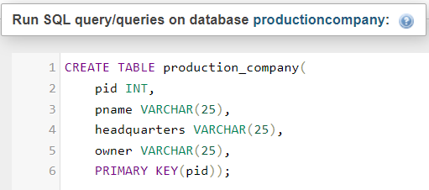

* Directors

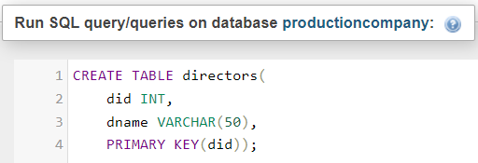

* Director_phno

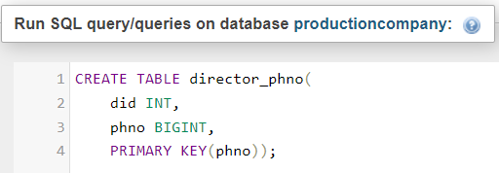

* Directed by

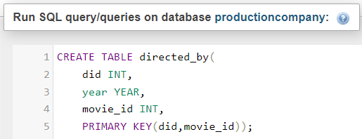

* Actors

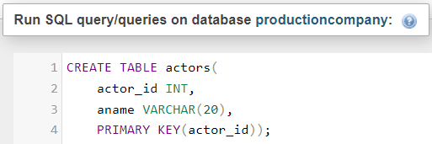

* Actor_phno

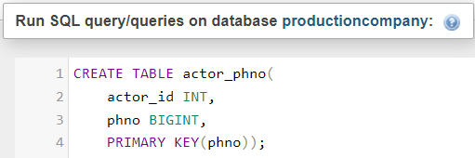

* Acts in

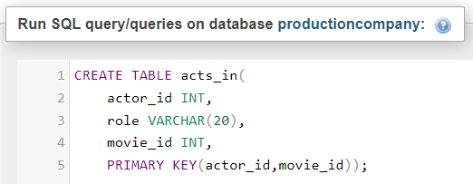

* Theatre

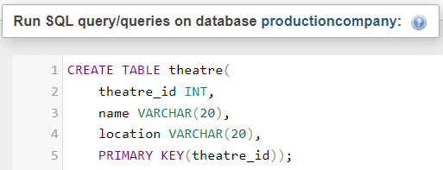

* Seats

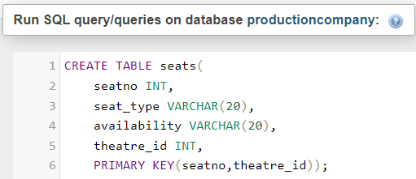

**3. Altering table to set FOREIGN KEYs**

* cid

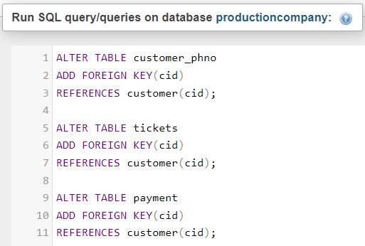

* movie_id

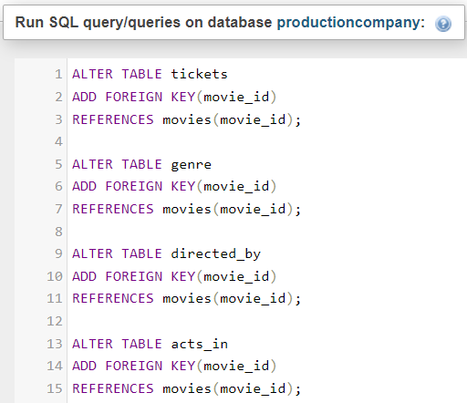

* theatre_id

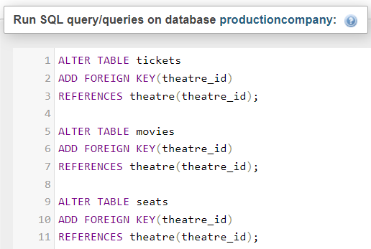

* pid

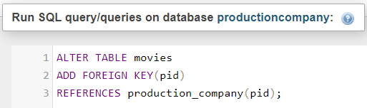

* did

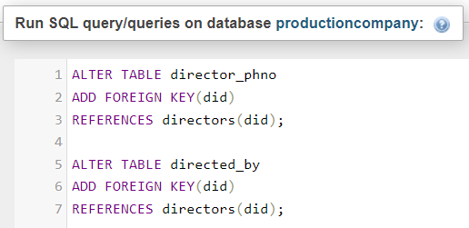

* actor_id

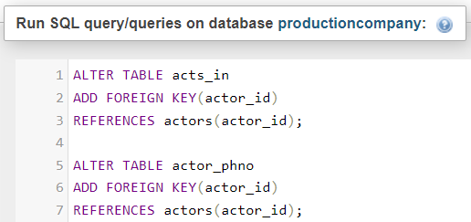

**4. Inserting entries**

* Customer

INSERT INTO `customer`(`cname`, `email`) VALUES

('Himalay','himalay@gmail.com'),

('Ishan','ishan@gmail.com'),

('Dikshit','dikshit@gmail.com'),

('Anjali','anjali@gmail.com'),

('Juby','juby@gmail.com');

* Customer_phno

INSERT INTO `customer_phno`(`cid`, `phno`) VALUES

('1','9586247'),

('2','8459698'),

('3','5589974'),

('4','8788999'),

('5','7889987');

* Payment

INSERT INTO `payment`(`refid`,`cid`, `payment_type`, `payment_status`, `payment_date`, `amount`) VALUES

('9','1','Cash','Completed','2019-03-02','220'),

('8','2','Cash','Completed','1995-03-02','50'),

('7','3','Net Banking','Failed','2017-03-02','110'),

('6','4','EWallet','Processing','2022-03-02','330'),

('5','5','Cash','Completed','2017-03-02','110');

* Actors

INSERT INTO `actors`(`actor_id`,`aname`) VALUES

('1','Ameer Khan'),

('6543','Amitabh B'),

('453','Kriti Sanon'),

('4657','Robert Downey'),

('653','Lokesh Patel');

* Directors

INSERT INTO `directors`(`did`,`dname`) VALUES

('432','Anurag Kashyap'),

('5467','Imtiaz Ali'),

('4657','Farhan Akhtar'),

('345','Rohit Shetty'),

('4365','Karan Johar');

* Theatre

INSERT INTO `theatre`(`theatre_id`, `name`, `location`) VALUES

('2354','PVR','Kochi'),

('875','PVR','Calicut'),

('654','Crown','Thrissur'),

('8675','IMAX','Kochi'),

('8657','PVR','Trivandrum');

* Production Company

INSERT INTO `production_company`(`pid`,`pname`, `headquarters`,`owner`) VALUES

('486','Yash Raj Films','Mumbai','Yash Chopra'),

('385272','Eros International','Mumbai','Kishore Lulla'),

('7857','Bhadrakali Pictures','Vishakpatnam','Pranay Reddy Vanga'),

('657','Raaj Kamal Films','Calicut','Kamal Hasan'),

('75','Amal Neerad Productions','Kochi','Amal Neerad');

* Actor Phone Number

INSERT INTO `actor_phno`(`actor_id`, `phno`) VALUES

('1','9422334455'),

('453','9422332455'),

('653','8222334458'),

('453','6742334455'),

('1','8322233455'),

('453','9522434455');

* Director Phone Number

INSERT INTO `director_phno`(`did`, `phno`) VALUES

('432','9944334422'),

('345','9942234422'),

('5467','9945634422'),

('4657','9945434422'),

('4365','9944343422');

* Directed by

INSERT INTO `directed_by`(`did`, `year`, `movie_id`) VALUES

('432','2019','23'),

('5467','1995','523'),

('4657','2017','346'),

('345','2022','3645'),

('4365','2017','634');

* Tickets

INSERT INTO `tickets`(`ticket_id`,`date`, `time`, `movie_id`,`cid`, `theatre_id`) VALUES

('1','2017-02-01','12:00:00','23','1','2354'),

('2','1995-02-01','21:00:00','523','2','875'),

('3','2019-02-01','16:00:00','346','3','654'),

('4','2022-02-01','14:30:00','3645','4','8675'),

('5','2017-08-06','12:00:00','634','5','8657');

* Seats

INSERT INTO `seats`(`seatno`, `seat_type`, `availability`, `theatre_id`) VALUES

('1','Recliner','available','2354'),

('5','Regular','booked','875'),

('2','Recliner','available','654'),

('3','Recliner','available','8675'),

('2','Recliner','available','8657');

* Movies

INSERT INTO `movies`(`movie_id`,`mname`, `pid`,`theatre_id`) VALUES

('23','TopGun','1','2354'),

('523','Airlift','1','875'),

('346','Lakshya','3','654'),

('3645','Mossad','4','8675'),

('634','Sanju','5','8657');

* Genre

INSERT INTO `genre`(`movie_id`, `genre`) VALUES

('23','Action'),

('523','Crime'),

('523','Romance'),

('346','Drama'),

('3645','Romance'),

('634','Action'),

('634','Romance');

* Acts_in

INSERT INTO `acts_in`(`actor_id`, `role`, `movie_id`) VALUES

(1,'Male lead','23'),

(6543,'Male lead','523'),

(453,'Female lead','346'),

(653,'Major Antagonist','3645'),

(4657,'Male lead','634');

**5. SQL Commands**

* CREATE/DROP DATABASE

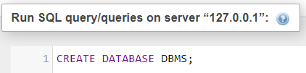

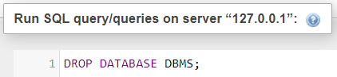

* Update an entry

UPDATE `movies` SET `mname`='AIRLIFT'

WHERE movie_id=523;

